**HTML Comments**

**What is comment?**

HTML comments are not displayed in the browser, but they can help you to read your HTML source code in your document.

**HTML Comment Tag:**

You can add comments to your HTML source by using the following syntax:



Notice that there is an exclamation point (!) in the start tag, but not in the end tag.

**Add Comments:**

With comments you can place notifications and reminders in your HTML code:

**Code:**

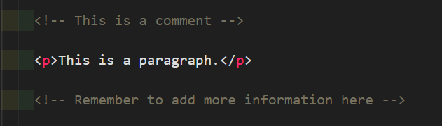

**Output:**

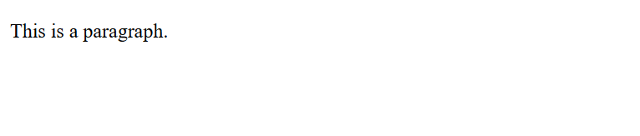

**Hide Content:**

Comments can be used to hide content.

This can be helpful if you hide content temporarily:

**Code:**

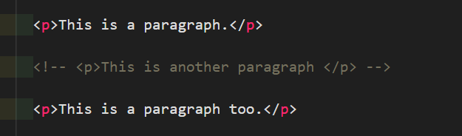

**Output:**

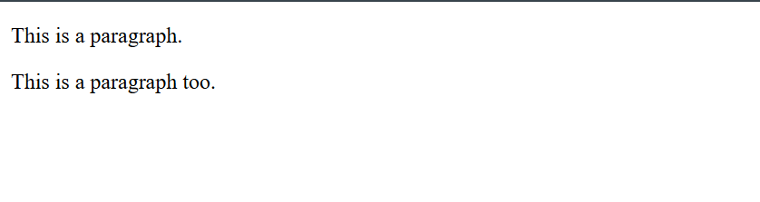

You can also hide more than one line. Everything between the <!-- and the --> will be hidden from the display.

**Code:**

**Hide a section of HTML code:**

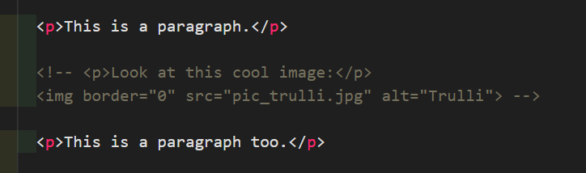

**Output:**

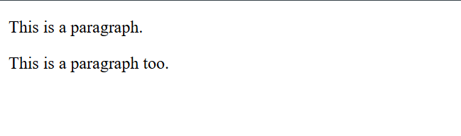

Comments are also great for debugging HTML, because you can comment out HTML lines of code, one at a time, to search for errors.

**Hide Inline Content:**

Comments can be used to hide parts in the middle of the HTML code.

**Code:**



**Output:**

